DCLDE 2024 PAMGuard Tutorial: Installation and Data Download

Douglas Gillespie, Marie Roch, Jamie Macaulay

This is the first of several documents intended to guide you through the tutorial exercises at the DCLDE PAMGuard workshop on 3 June 2024

Laptop Spec: The software has all been developed on Windows, and although there are Mac installers for some older versions, the version you’ll be running in the tutorial is Windows only. If you are using a Mac, then you should be able to use Boot Camp. A minimum spec for the laptop is

* AMD or Intel x86 processor (not ARM which you’ll find on some new machines)
* Windows 10 or above
* A HD Screen (at least 1920 x 1080)
* Min 8 Gigabyte RAM
* 25 Gigabytes drive space for data files

Please complete the instructions in this document PRIOR to travelling to DCLDE 24. You will be required to install software on your computer, which may require admin rights from your IT managers and there are also some quite large data downloads which might use up a lot of the valuable time we have available to us in Rotterdam. Please read right to the end of this document and make sure that you’ve started PAMGuard and loaded the Deep Learning module, which will automatically download additional software it needs that’s specific to your computer and graphics card.

Any questions regarding installation and data download should be addressed to Doug Gillespie [dg50@st-andrews.ac.uk](mailto:dg50@st-andrews.ac.uk).

Contents

1 Software Installation 2

1.1 PAMGuard download and Installation 2

1.1.1 Add the Batch processing plugin 3

1.2 Tethys Download and Installation 3

1.3 SQLite Studio 6

2 Data Download 7

2.1 Deep Learning Tutorial 7

2.2 Tethys 7

2.3 Batch Processing 7

2.4 Summary data table. 7

# Software Installation

The installation folder contains three items. A pre-release version of PAMGuard (2.02.11c) with Tethys & deep-learning modules, a PAMGuard plugin for batch processing, and a pre-release version of Tethys (3.1 PG).

When executing software that has been downloaded, Windows may provide the following warning:

This is standard Windows policy for downloaded executables and is not a virus scanner warning. Click on the ‘More Info’ link and then select ‘Run anyway’. You should only be asked this once.

## PAMGuard download and Installation

The latest ‘official’ PAMGuard release available at pamguard.org does not contain the latest versions of the Tethys and the Deep Learning modules that you’ll need for the tutorial. A pre-release that you will need for the tutorial, currently V2.02.11c, is available for download from <https://drive.google.com/drive/folders/16svF98m85t-4c9viOiPX8Tz5JQYib7sz?usp=sharing>. Download Setup-Pamguard_2_02_11c.exe and install on your computer in the normal way.

PAMGuard’s deep learning module automatically downloads required library files to a hidden folder the first time you run a deep learning module. These files are operating system and hardware specific; for example, PAMGuard will download different set of files depending on the type of graphics card you might have to optimise processing speed. So that we don’t have lots of folk downloading at the start of the tutorial it’s best to download the files before the tutorial. To do this, open a blank PAMGuard configuration. Click ***File -> Add Modules-> Classifiers -> Deep Learning Classifier*** to add the deep learning module (it will also ask to add a Sound Acquisition module). Go to ***Settings-> Raw Deep Learning Classifier*** and click the three dots at the bottom of the settings dialog. Then select right whale and click ***Import*** as show below. It might take a few minutes to complete but you are good to go when done!

If your administrator will not allow you to install this software, then please contact Doug Gillespie.

### Add the Batch processing plugin

The Deep learning and Tethys modules are built into PAMGuard. However, the batch processing module is a separate ‘plugin’. To install this, download the Batch_Processing_1_4.jar file from the plugins folder at the link above and then copy this file into the folder C:\Program Files\Pamguard\plugins\.

Notes:

* If you downloaded the entire plugins folder, the batch processing jar file will be in a zip file that you must extract.
* If you installed PAMGuard to C:\Program Files\Pamguard, you may need administrative privileges to write to the plugins folder. If you installed PAMGuard elsewhere, then find the appropriate plugins folder for your installation.

## Tethys Download and Installation

The Tethys software is distributed as a single zip archive that is downloaded from the [same folder as the PAMGuard installer](https://drive.google.com/drive/folders/1iR9KMIbyqZyiDwhqQXP0OrQx0twqVWj_?usp=sharing). Download Tethys-3_1-DCLDE-Prerelease.zip and unzip it to a location of your choice. The download is approximately 2 GB and it will require about 18 GB on your machine. The vast majority of the size is attributable to the content of the databases that are distributed with the installer. The unzip functionality that is bundled with Windows can be very slow, if you have a dedicated zip archive manager such as WinRAR and 7Zip we recommend that you use these as they are at least an order of magnitude faster.

Tethys consists of a server program that manages the database, a set of client programs that can communicate with the server, documentation, database directories that contain a demonstration database that contains sample data (demodb) and a blank database (metadata). The programs and data in the zip archive have the following folder structure:

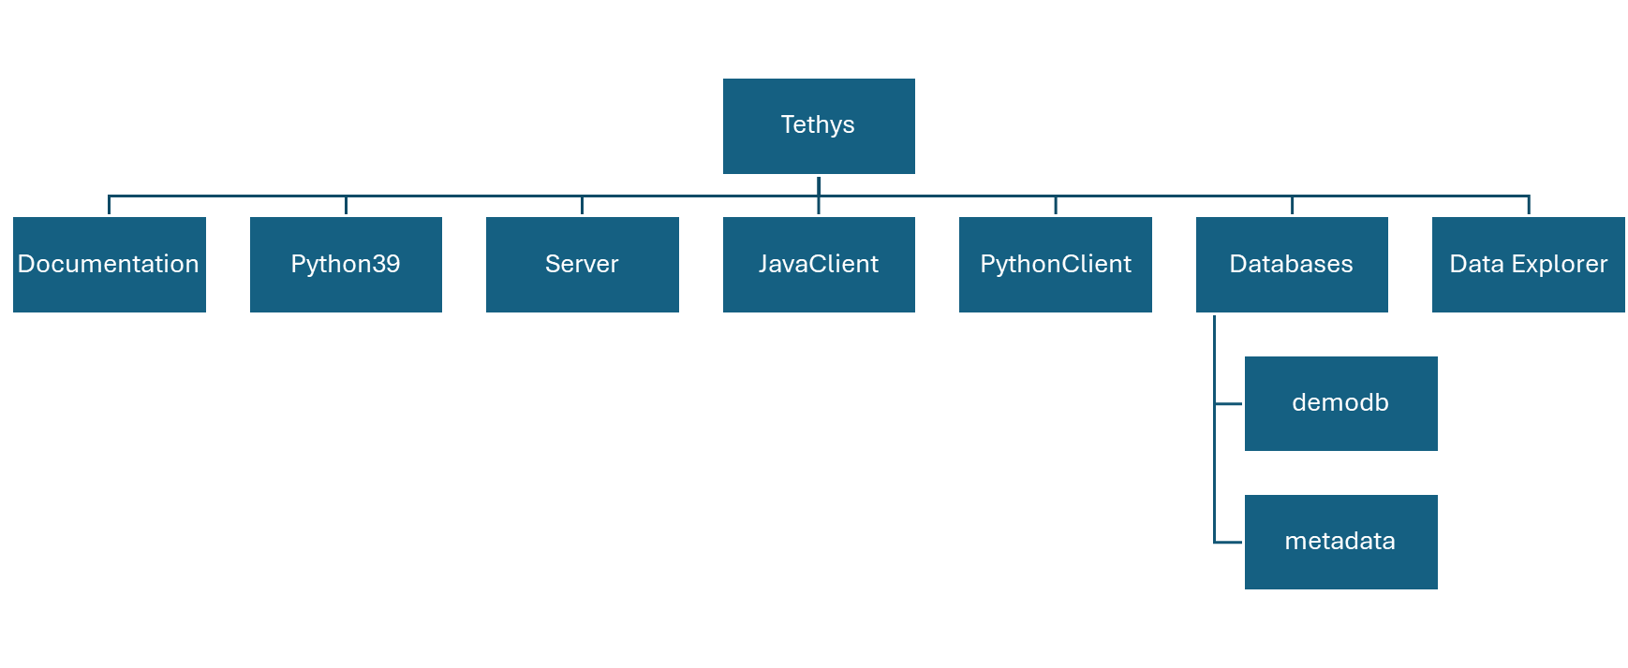Figure 1 – Folder structure of Tethys

PAMGuard sends DCL data to Tethys in a format it can understand directly. If you wish to use other sources such as importing from spreadsheets or databases, additional software must be installed. See the installation chapter in the Tethys server guide for details. Additional software is also required if you wish the web client to export data in a hierarchical R data format.

To test the server, navigate to the folder and double click on the tethys.bat file. Some system administrators restrict this functionality, and if that does not work, you can open a command line shell and navigate (via the cd command) to Databases\demodb. Type tethys.bat and press enter. When Tethys starts, Windows Defender may throw a warning at you at this point:

The Tethys server is written in Python and you are likely to be prompted to allow Python to communicate over the network (Fig. 2). Tethys “talks” to client programs on port 9779 and this must be enabled before clients can communicate with Tethys. More information on the firewall is in the Tethys server manual.

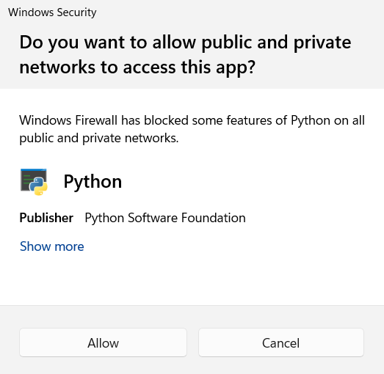

Figure 2 – Firewall notice when Tethys starts. Windows is asking permission to allow the database server to communicate over a network port. This is required for the Tethys server to communicate with PAMGuard as well as client tools such as the DataExplorer.

After approving the network access, you should see something similar to the following output:

[15/May/2024:11:02:51] Welcome to Tethys, 3.1 - Server starting...

No server configuration file at ...\Tethys\ServerDefault.xml (not an error), using internal defaults

Examining logs in ...\databases\demodb\db to verify that database is correct.

Log processing started at 2024-05-15 11:02:51.362099

Cache size set to 1.00 GB

Log processing complete. started at: 2024-05-15 11:02:51.362099 elapsed 0 days 00:00:00.329252

Checkpointing database ...\databases\demodb\db... checkpoint complete

Cache size set to 1.00 GB

BSDDB environment initialized

Starting DB XML in transactional mode

Query cache: 128 GB at C:\Users\marie\AppData\Local\Temp\tethys-build\databases\demodb\diskcache, enabled=True

Cannot start R, environment variable "R_HOME" is not set

[15/May/2024:11:02:55] ENGINE Bus STARTING

[15/May/2024:11:02:55] ENGINE Started monitor thread 'Autoreloader'.

[15/May/2024:11:02:56] ENGINE Serving on http://0.0.0.0:9779

[15/May/2024:11:02:56] ENGINE Bus STARTED

[15/May/2024:11:02:57] Web interface at http://vaquita:9779/Client

[15/May/2024:11:02:57] R programming language interface unavailable

Next, test that you can communicate with the server. The easiest way to do this is from a web browser. Type localhost:9779/Client and the web client should load (Fig. 3).

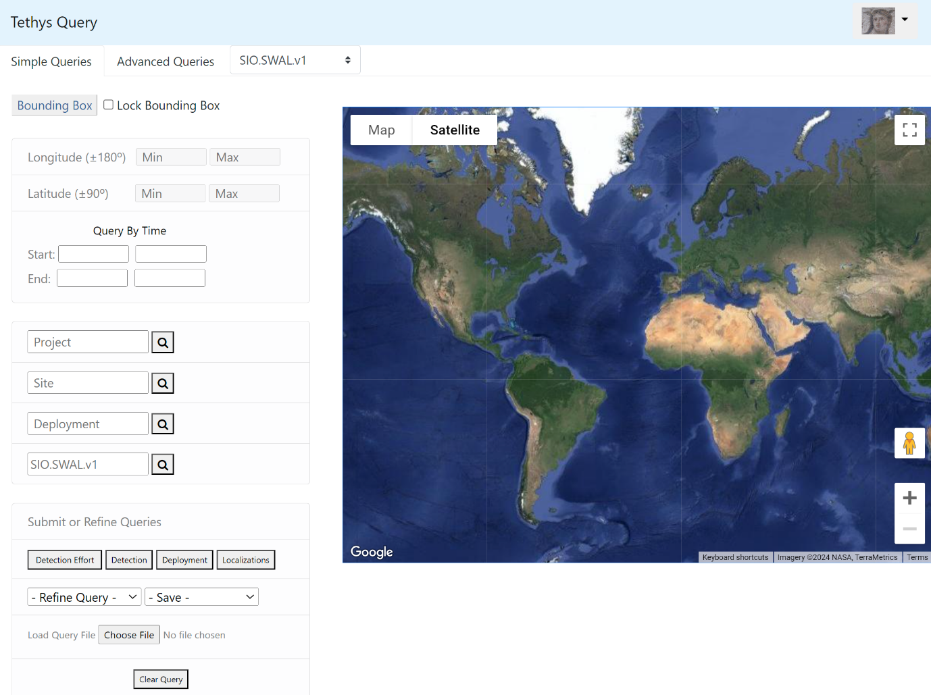

Figure 3- A web client is accessible at <http://localhost:9779/Client>.

Press Deployments and you should see the locations of the instrument deployments stored in the demonstration database after a short delay. If you wish to ensure that everything is ready before the workshop, you may want to try the following additional steps:

* If you wish to save from the web client in R’s data.tree format (requires an R library available from CRAN), you will need to install R on your machine and let Tethys know where to find it. See directions in the Tethys manual (Documentation/Tethys.pdf), section “R installation for data export” (page 9 as of this writing).
* If you are a Matlab user, we also recommend that you test the Matlab client prior to the workshop. Directions on setting it up are in the Matlab Cookbook in the documentation folder.
* We recommend that you verify that the data explorer is working, follow the instructions in Documentation/DataExplorerManual.pdf to start it.

## SQLite Studio

PAMGuard mostly uses sqlite databases. These are single file databases which reside on your machine or shared drive. They can easily be opened with Matlab, R, or most other programming languages. Being able to view the database content directly isn’t necessary for any of these exercises, but if you do want an easy look into the PAMGuard databases you’ll need to install SQLiteStudio which you can download from <https://sqlitestudio.pl/>

# Data Download

All of the audio and PAMGuard data that you’ll need (apart from the Tethys database) are on the google drive at <https://drive.google.com/drive/folders/1p1NhuxnRDi9L2qifZhRpMnZVXLhxBaf8?usp=sharing>

The total volume of all the example data we’re using in the exercises is around 3 GBytes. You can install these data anywhere on your computer, or on an external hard drive if that’s more convenient. If you’re really short of space, then just download the ‘Essential’ files, which will allow you to complete most of the morning exercises. You’re also welcome to bring your own data to the tutorial.

## Deep Learning Tutorial

For the Deep Learning (DL) tutorial, we’ll be working with right whale sounds, initially using the dataset prepared for the 2013 DCLDE meeting in St Andrews. During the tutorial, there won’t be time to process the full four days of data, so we’ve cut out one hour of data, which should process in a few minutes on most computers. This is in the file **NARWOneHour.zip**

## Tethys

An hour’s data isn’t really enough to demonstrate Tethys, so we’ll be using four days of data from the 2013 meeting. These data have already been processed with PAMGuard, so you don’t need all of the raw wav data, just the PAMGuard database and the binary files from the detectors, which are available in the file **NARWDCLDE2013_4Days - Viewer.zip**. If you want to view the data with spectrograms though, you should also download the raw audio file which are in **NARWFourDays.zip**.

## Batch Processing

To understand how the batch processor works, we’ll be using one days data from this years workshop. This comprises 36 simultaneous sonobuoy deployments. A single PAMGuard project cannot manage files that overlap in time, so these need to be each processed separately. To make the data compatible with the other exercises we’ve modified the data slightly by pulling out a single channel, dropping the sample rate to 2kHz and chopping the long files up into 15 minute chunks. These data are all in **DCLDE24_SingleChannel2kHz.zip**.

## Summary data table.

All of the datasets you require are in a google drive folder at <https://drive.google.com/drive/folders/1p1NhuxnRDi9L2qifZhRpMnZVXLhxBaf8?usp=sharing>

You should download and unzip these files before attending the workshop.

|  |  |  |  |
| --- | --- | --- | --- |
| Tutorial | Dataset | File archive | Essential |
| DL | One hour of wav files with right whale calls | NARWOneHour.zip | Yes |
| DL/Tethys | Four days of wav files with right whale calls | NARWFourDays.zip | No |
| DL | Four days of processed right whale data | NARWDCLDE2013_4Days - Viewer.zip | Yes |
| Batch | Data from 35 sonobuoy deployments | DCLDE24_SingleChannel2kHz.zip | Yes |